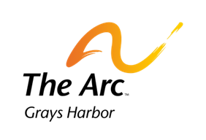

SUMMER INTERN PROGRAM REPORT
August 17, 2017
Submitted by
Jeff Meeks & Doreen Harden-Cato, Ed. D
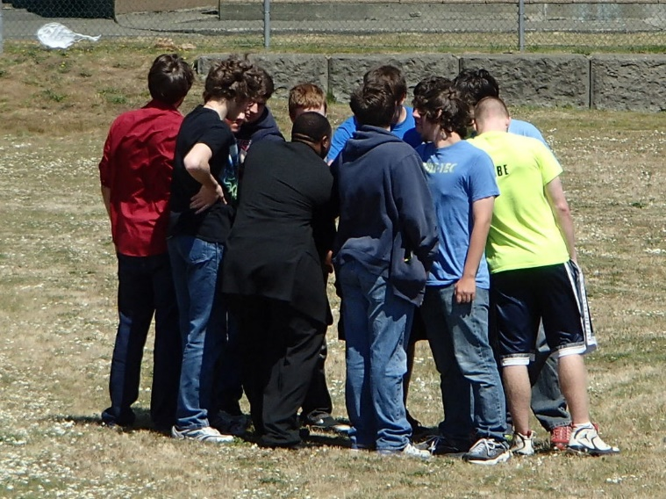

SUMMER INTERN SUMMARY REPORT

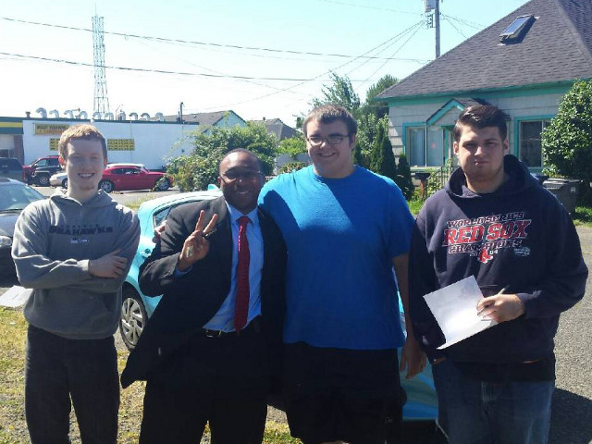
This is the second year of the Summer Job Program sponsored by Pacific Mountain Workforce Development Council. The Arc of Grays Harbor County was the primary grantee who contracted with Grays Harbor Youth Works to assist them in recruiting students and employer hosts. Both were responsible for assisting PACMTN and DVR with providing UpLift job readiness training to the summer interns. This training was met with enthusiasm from the participating youth. The week-long training was conducted by three individuals from AmeriCorps.
The other responsibilities were to conduct 1-on-1 orientations between the mentor and intern; have the proper paperwork completed on each intern; conduct on-site monitoring, job coaching; and providing interventions when necessary.
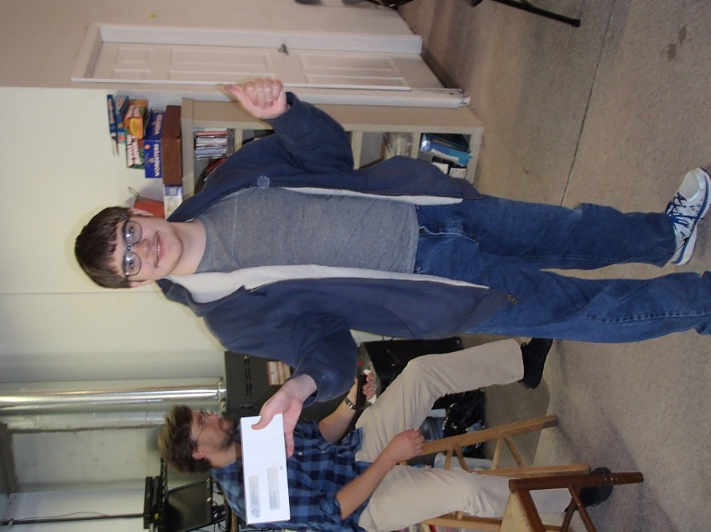
There were four businesses, three nonprofits and two public sector employers who hosted the nine interns. The hosts in Ocean Shores were Give Me Paws and the Public Library; Hoquiam’s hosts were Polson Museum and Habitat for Humanities; Aberdeen’s hosts were The Arc, Grays Harbor Historical Seaport Authority, and Catholic Community Services Feed the Hungry; and in East Grays Harbor County Elma Timberland Library.
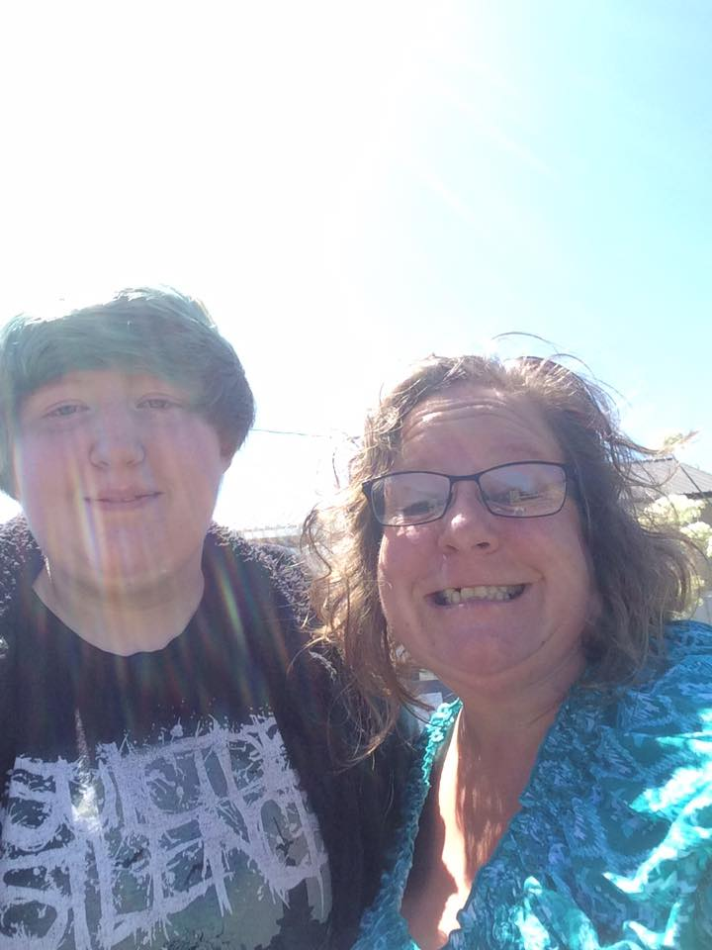
The program lost one intern midway through the internship. This student was still counted in the evaluation. Each student and mentor received an evaluation after three weeks by the assigned person from The Arc and Grays Harbor Youth Works. The first evaluation was a hardcopy and the second one was distributed through Survey Monkey. The purpose of the final evaluation was to see if the challenges identified earlier had improved.

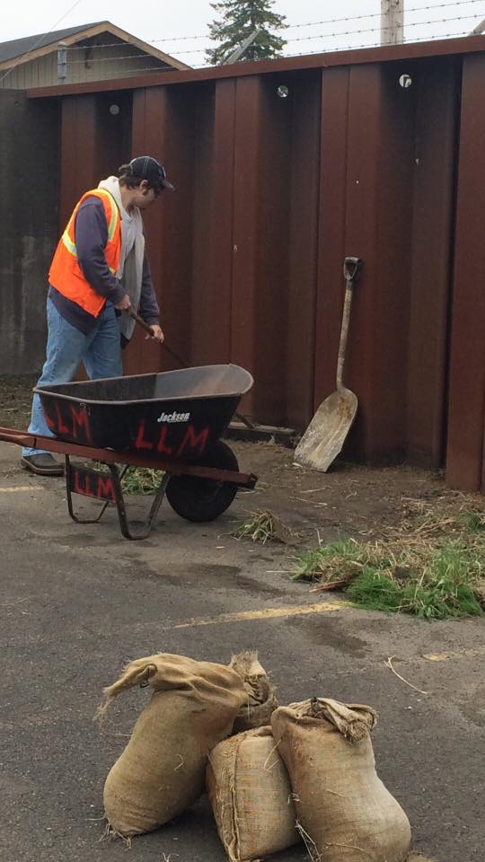
The soft skills evaluation complimented the Uplift training which responded to surveys by 2014 Washington Workforce Development Education Board and Chambers of Commerce and 2016 Greater Grays Harbor, Inc. employer surveys. The studies mirrored each other. The same findings were echoed in the 2014 Workforce Development Education Board and Washington Chambers of Commerce from 2300 plus employers around the state and 100 employers within Grays Harbor County.
Both survey results identified 85% of employers in Grays Harbor County were hesitant in hiring high school and college graduates from the area.
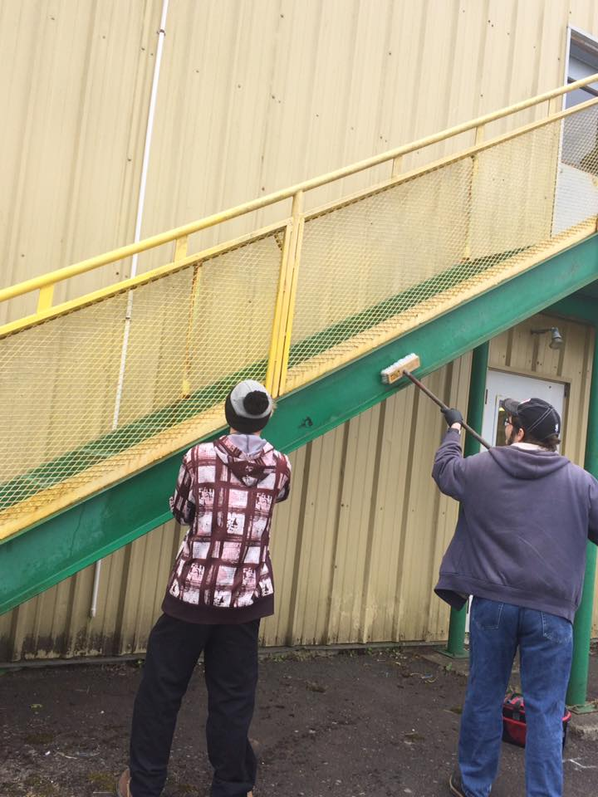
They also identified 63% of employers found it a challenge to retain recent hires from high school and in some cases Grays Harbor College due to lack of soft skills or work habits. GGH also learned that many employers in Grays Harbor go outside the county for their needed expertise.
Intern Evaluation Methodology
The evaluation was distributed among those individuals who were given the responsibility to work with the intern throughout the six-seven weeks or until the completion of 55 hours. There were 10 evaluations distributed throughout Grays Harbor County. There was a total of nine interns with one having two mentors, which is why there were 10 responses to the evaluation.
The evaluation focused on the development of the intern’s soft skills. These soft skills were: attendance, ability to work independently, dressing appropriately, communication, teamwork, taking directions, completing a task, and being able to work with a mentor/coach/supervisor. The results illustrated the students' soft skills, also known as people skills. This evaluation also addressed how to best interact and work with others so one can build meaningful work relationships; influence others’ perception of oneself, and motivate his/her own actions. The weighted average is based on five (5.00) possible points.
The evaluation had the same questions that were on the hardcopy for comparison. Overall, most of the results indicated growth in all areas, except for one exception. This is contributed to the intern who had left early in his internship.
The evaluation is helpful with enabling us to focus on specific skill-building for job readiness in future trainings.

SOFT SKILLS EVALUATON | NEEDS  DEVELOPMENT ON 4-5 SOFT SKILLS– | NEEDS COACHING ON 1-3 SOFT SKILLS– | ABLE TO DEMONSTRATE MOST SOFT SKILLS– | PROFICIENT IN SOFT SKILLS– |  | EXEMPLARY IN PERFORMANCE OF SOFT SKILLS– | TOTAL– | WEIGHTED AVERAGE–
–  Attendance: Understanding work expectations for attendance and adhering to them. Notifying supervisor in advance in case of absence. | 0.00%  0 | 0.00%  0 | 0.00%  0 | 60.00%  6 |  | 40.00%  4 | 10 | 4.40
–  Taking Initiative: Participating fully in task or project from initiation to completion. Initiating interaction with supervisor for next task upon completion of previous one. | 0.00%  0 | 20.00%  2 | 10.00%  1 | 50.00%  5 |  | 20.00%  2 | 10 | 3.70
–  Punctuality: Understanding work expectations for punctuality. Arriving on time for work, taking and returning from breaks on time, and calling supervisor prior to being late. | 0.00%  0 | 10.00%  1 | 0.00%  0 | 70.00%  7 |  | 20.00%  2 | 10 | 4.00
–  Workplace Appearance: Dressing appropriately for position and duties. Practicing  personal hygiene appropriate for position and duties. | 0.00% | 10.00%  1 | 10.00%  1 | 70.00%  7 | 10.00%  1 | 10 | 3.80
–  Communication Skills: Using language appropriate for the work environment. | 10.00%  1 | 0.00%  0 | 20.00%  2 | 40.00%  4 | 30.00%  3 | 10 | 3.80
–  Able to learn new skills: Open to acquiring new ways of doing something; adaptable. | 0.00%  0 | 11.11%  1 | 22.22%  2 | 44.44%  4 | 22.22%  2 | 9 | 3.78
–  Behaves in a professional matter: Always courteous; smiles when appropriate; helpful to customers or co-workers when necessary. | 0.00%  0 | 0.00%  0 | 10.00%  1 | 50.00%  5 | 40.00%  4 | 10 | 4.30
–  Team player: Works with co-workers when necessary; when finish with one's work volunteers to help another team mate complete his/her task when possible. | 0.00%  0 | 0.00%  0 | 11.11%  1 | 77.78%  7 | 11.11%  1 | 9 | 4.00
–  Works with Coach/Mentor: Listens to supervisor/mentor; ask supervisor/mentor questions when necessary; and meets at least once a week. | 0.00%  0 | 11.11%  1 | 0.00%  0 | 77.78%  7 | 11.11%  1 | 9 | 3.89
–  Able to complete a project/assignment: Completes the assigned task with or without additional direction | 0.00%  0 | 11.11%  1 | 0.00%  0 | 55.56%  5 | 33.33%  3 | 9 | 4.11

– | POOR– | FAIR– | VERY GOOD– | EXCELLENT– | TOTAL– | WEIGHTED AVERAGE–
–  Working with the student | 0.00%  0 | 10.00%  1 | 60.00%  6 | 30.00%  3 | 10 | 3.20
–  Receiving help when requested | 0.00%  0 | 0.00%  0 | 55.56%  5 | 44.44%  4 | 9 | 3.44
–  GHYW Orientation | 10.00%  1 | 10.00%  1 | 40.00%  4 | 40.00%  4 | 10 | 3.10

Q3. Mentors’ Feedback on How can we improve the program?

I think it is good. I enjoy being a part of the program.

We enjoyed the opportunity to participate in such a wonderful program and honored to host an intern. I do not have notes for improvement now.

Perhaps more notice about the program and the person who will be working in our location.

INTERNS’ LEARNING JOURNALS

Casey/The Arc
Learned to work with staff, and completing my tasks cleaning, mowing, collecting clothing and other donations. I also learned to organized files and maintain the office when directed. Enjoyed going to different places collecting donated items.

Joey/Elma Timberland Public Library
I learned to take inventory, returning books back to the shelves in alphabetical order. I had an opportunity to assist adults, children, and youth with the computer, showing them how to use Word, Excel, PowerPoint, publisher, or play games. I fixed computers in the library and read to the young kids.

Moses/Ocean Shores Public Library
I learned to do inventory, collect books to put back on the shelves by authors last name. I checked out and received returned books. I learned how to operate the cash register. I enjoyed helping people on the computers and reading to the young kids.

INTERNS’ LEARNING JOURNALS

Nathan/Grays Harbor Historical Seaport Authority
I was responsible for maintaining the grounds, shop, and painting a building. I assisted crew on the Tall Ships, when they were docked.

Brendan/Grays Harbor Historical Seaport Authority
I assisted crew on the Tall Ships, when they were docked and helped Nathan with painting the trim on a building. I worked with Scott my mentor in the shop area, being responsible for keeping the shop clean; and maintaining the grounds. My favorite thing to do was working on the Tall Ships.

Robert/CCS Feed the Hungry
I met with the staff and people seeking help. I was responsible for setting up the tables to get them ready for lunch time. I help to fix the lunches by cracking eggs, serving and cleaning up the room when lunch was over. I liked working alone and sometimes with staff. I sometimes worked in the office shredding paper and keeping it clean. I like handing out ice cream and giving people gifts.

INTERNS’ LEARNING JOURNALS

Taelin/Give Me Paws
I learned how to take payments and work the register, groom dogs by clipping their nails and later shampooing; I became efficient with vacuuming, filing, and using the computer to do data entry on excel program. I was responsible for keeping dogs’ area clean and vacuuming after haircuts and clippings. I enjoyed playing with the dogs to keep peace and quiet.

Zeb/Habitat for Humanity
I was taught how to give customers’ service by helping people when they donated items and working with others to unload and clean the items. I helped to get the furniture and other things out on the show room.

